

HR Data Analysis Answers

1. Data Import and Transformation: Can you show me how to import the employee data from the Excel files and transform it to remove any unnecessary columns or rows?

Here are the steps to import the employee data from the Excel files.

1. Open **Power BI Desktop** and select Excel Workbook **or text/CSV** from the **get data** option.

1. Select the files one by one present in the PBI-TAB- HR_Data_Analysis folder.

1. Wait for the **Navigator** to open, select the files to load and load the data which can be transformed later.

After loading the data, we need to clean and transform the data. We need to ensure that the data is consistent, doesn’t contain null, NaN or empty values, all the columns are of the right data type, there are no unnecessary columns and lastly no outliers.

**Since all the columns are required for analysis, I have not removed any columns.**

We can use the **column quality tool** to check for percentage of valid values, values with errors and values which are empty.

We can then use the **column profile tool** to check the value distribution and check key column statistics like Min, Max, Average and Standard Deviation to eliminate the outliers if any.

1. Basic Visualization: Create a simple bar chart to visualize the distribution of employees by department.

1. Filtering Data: How can you create a slicer to allow users to filter employees based on their job role in Power BI?
2. To create a slicer we need to select the slicer visual from the Visualization pane.

1. Then we need to drag the field which we require i.e. Job Role and drop it into the visual or the field section of the visual.

1. Then we need to do select the type of visual and apply the desired formatting to it.

1. Joining Data: Explain what kind of join you would use to combine the employee data with the in-time and out-time data, and why.

In order to combine the employee data with the in-time & out-time data, we need to use a left-join to join the Employee data with the in-time & out-time data each as we need all the data from the employee table but only the matching data from the in-time & out-time data which satisfies the join condition.

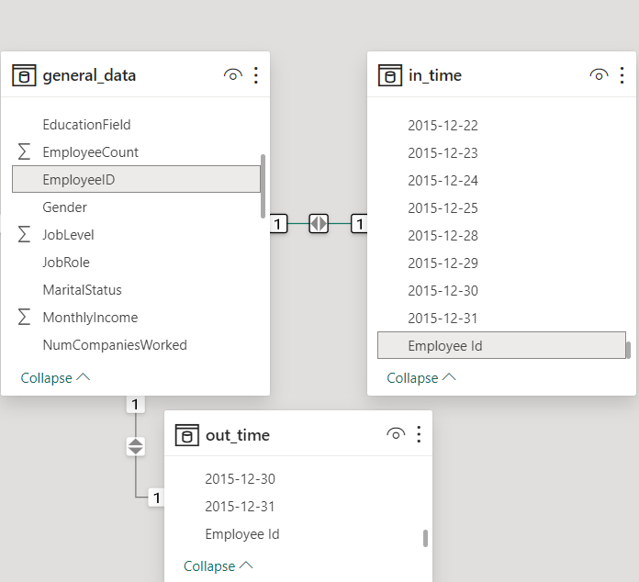

1. Calculated Columns: Create a calculated column to determine the age group of employees (e.g., under 30, 30-40, 40-50, over 50).

AgeGroup = IF(general_data[Age] < 30, "under 30", IF(general_data[Age] >= 30 && general_data[Age] <40, "30-40", IF(general_data[Age] >= 40 && general_data[Age] <=50, "40-50", IF(general_data[Age] > 50, "over 50", "NA"))))

1. Measures in DAX: Calculate the average monthly income for employees and display it in a card visualization.

Average Monthly Income = AVERAGE(general_data[MonthlyIncome])+0

1. Time Intelligence: How can you use DAX to calculate the year-over-year growth in monthly income for employees?

Since we have data only for the year of 2015, it is not actually possible to calculate the YOY growth in monthly income. But, we do have the Percent Salary hike from which we can calculate the previous year’s salary and hence,

**YOY Growth in salary = Percent Salary hike**

We can alternatively calculate the average of the Percent Salary hike to compute the YOY Salary Growth %.

YOY Salary Growth = AVERAGE(general_data[PercentSalaryHike])

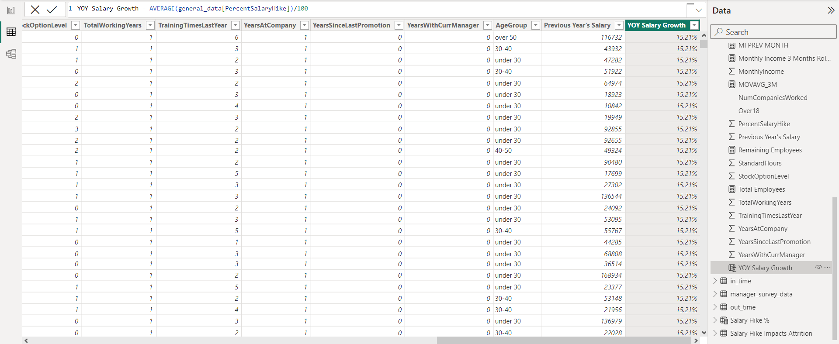

1. Hierarchies: Create a hierarchy for the date and time columns to allow for easy drill-down analysis.

Since the date-time information in the in-time & out-time data is of type text and cannot be converted to date-time because of NA values, I have created a calendar table using the DAX formula below.

Calendar = CALENDAR(DATE(2015,01,01), DATE(2015,12,31))

Using this, a date table is created for the year 2015 and this also generates a date hierarchy automatically as shown below.

1. Advanced DAX Calculation: Calculate the attrition rate for each department and visualize it using a heatmap.

Firstly to calculate the attrition rate, we need to calculate the total employees, employees left, remaining employees, average employees and then calculate the attrition rate.

Total Employees = COUNT(general_data[EmployeeID])+0

Employees_left = CALCULATE(COUNT(general_data[Attrition]), general_data[Attrition] = "Yes")

Remaining Employees = 'general_data'[Total Employees] - 'general_data'[Employees_left]

Average_Employees = ('general_data'[Total Employees]+'general_data'[Remaining Employees])/2

Attrition_Rate = ([Employees_left]/[Average_Employees])

Then we need to create a Tree Map based on the department details and value of the attrition rate which automatically splits the attrition rate by each department.

1. Advanced Join: Combine the employee data with a different dataset using a left join and explain the potential pitfalls.

After modelling the data and building a suitable model by establishing proper relationships, there is no need to join the data sets as it is unnecessary and rather use a normalized data model.

But we could still left join general data with employee survey data and merge them and then left join this merge with manager survey data based on employee id. It would result in no major pitfalls but would consume time and therefore it is better to have a normalized data set with joins.

Using the **merge queries as new** to left join general data with employee survey data to produce Merge1.

Expanding all the columns of employee survey data in Merge1.

Using the **merge queries as new** to left join Merge1 data with manager survey data to produce Merge2.

Expanding all the columns of manager survey data in Merge2.

As you can see this is a time-consuming process and it would result in no major pitfalls. But it is better to have a normalized data set with joins in this case.

1. Complex Filtering: Create a dynamic filter that allows users to filter employees based on both department and job role simultaneously.

To create a dynamic combo filter we can use a slicer and add both the department and job role fields to simultaneously filter based on department & job role as shown below.

12. Advanced Time Intelligence: Calculate the moving average of monthly income over a rolling 3-month period using DAX.

Monthly Income 3 Months Rolling Average = VAR PeriodToUse = DATESINPERIOD ('Calendar' [Date], LASTDATE ('Calendar' [Date]), -3, MONTH) VAR Result = CALCULATE (AVERAGE ( general_data[MonthlyIncome] ), PeriodToUse) VAR NMonthsPeriodBlank = if ( [AVG MI] = BLANK (),0,1) + if ( [MI PREV MONTH] = BLANK (),0,1) + if ( [MI 2ND PREV MONTH] = BLANK (),0,1) RETURN IF (NMonthsPeriodBlank < 3, BLANK (), Result)

The moving average of monthly income over a rolling 3-month period can be calculated using the formula above. But since we have the data only for the year of 2015 and salaries are constant throughout the year it is the same as Average monthly income.

1. Conditional Formatting: Apply conditional formatting to a table to highlight employees with the highest and lowest monthly incomes.

I have applied conditional formatting to both MonthlyIncome and Employee ID based on Background color.

Conditional formatting rules for Monthly Income

Conditional formatting rules for Employee ID.

1. Parameter Tables: How can you use parameter tables to allow users to set their own thresholds for performance ratings and visualize the results?
2. Custom Visualizations: Create a custom visual or use a third-party visual to present data in a way that's not available in the default Power BI visuals.

I wasn’t able to use a custom visual as it requires me to login and have a Pro license which I cannot afford just for the sake of a few custom visuals.

1. Aggregations: Explain how to optimize performance by creating aggregations for large datasets.

Creating aggregations for large datasets in Power BI can significantly improve query performance. **We can simply use the Group By option in transform data to aggregate the data and reduce the volume of data.**

Additionally, Here’s a step-by-step guide on how to do it:

**Creating Aggregation Tables**: Depending on the data source type, an aggregation table can be created at the data source as a table or view, as a native query, or for the greatest performance, as an import table created in Power Query.

**Defining Aggregations**: Use the Manage aggregations dialog in Power BI Desktop to define aggregations for aggregation columns with summarization, detail table, and detail column properties.

**Managing Aggregations**: In the Fields pane of any Power BI Desktop view, right-click the aggregations table, and then select Manage aggregations. The Manage aggregations dialog shows a row for each column in the table, where you can specify the aggregation behavior.

**Validations**: The Manage aggregations dialog enforces validations. For example, the Detail Column must have the same datatype as the Aggregation Column, except for the Count and Count table rows Summarization functions.

**Using DAX Measures**: In an all-imported model, you can use DAX measures to switch between the aggregated and the main table.

Remember, aggregations in Power BI can improve query performance over very large DirectQuery semantic models by caching data at the aggregated level in-memory. They can be manually configured in the data model, or for Premium subscriptions, automatically by enabling the Automatic aggregations feature in model Settings.

1. What-If Analysis: Use What-If parameters to show how attrition rates change when you adjust different factors (e.g., salary increase).

Firstly, I have used the **key-influencer visual** to come up with a **trend**. In this case, **the average attrition rate decreases by 2.03% when the average monthly income is raised by 5507.27 i.e. a salary hike of 8.5 %.**

Based on this trend, I have manually created a table and entered the data named Salary hike impacts Attrition Rate.

Then to create a what-if parameter, I selected the new parameter option from the modelling tab and selected a numeric range parameter based on the values in the Salary hike % column of the Salary hike impacts Attrition Rate table.

After this a Salary Hike % slicer got automatically added which I have formatted. Then I added some cards to show Average Attrition decrease and amount increase, attrition rate and the projected attrition rate as well.

The data shown in this screenshot is for a Salary hike of 16%.

The cards update the values when we select any random value for salary hike using the slider-slicer.

The data shown in this screenshot is for a Salary hike of 20%.

1. Cross-Filtering: Demonstrate the use of cross-filtering between visuals to provide an interactive experience for users.

Relevant Visuals in all the tabs are set to filter each other rather than highlighting.

Assessment answers tab without any cross filtering.

After clicking on the male slice of the pie-chart, we can see that the visuals are filtered to show the data for male employees only.

1. KPIs: Create Key Performance Indicators (KPIs) for employee performance using DAX calculations.

I have used the average ratings for Job Involvement, Performance, Job Satisfaction, Environment Satisfaction and Work – Life Balance in the visuals without using any DAX as shown below.

For all the KPIs above, I have used a Goal measure which is sets the goal to 3.

Goal = 3

So now the KPI visuals show the average rating in green when it is above the Goal and in red when the goal is not met.

1. Dynamic Reporting: Show how to make a report dynamic by using bookmarks and buttons to switch between different views of the data.

For this, I have created 4 bookmarks which are HR, R&D, Sales and Back.

Then I have created 4 buttons, one for each department and other for going back and have enabled a bookmark action respectively for all the buttons.

Without clicking on the HR button.

After clicking on the HR button, we are navigated to the Attrition Rate Insights tab which shows the data only for the HR department.

After clicking the back button, we are redirected back to the assessment answers tab.

Here is a link to the related LinkedIn post which also has a link to my presentation of the report.

<https://www.linkedin.com/posts/nik995_hr-analysis-report-activity-7150140174369198082-FSRH?utm_source=share&utm_medium=member_desktop>